Atomic Structure PhET: **E/M Waves Name: ____________________________**

**Score: _____ / 10**

**Goal**: To investigate relationships between frequency, wavelength and energy of emitted photons of light.

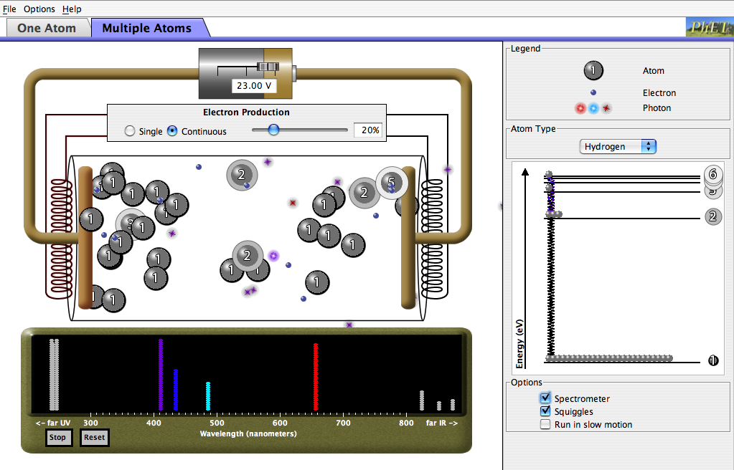

Open the PhET model, [“Neon Lights and other Discharge Lamps”](http://phet.colorado.edu/sims/discharge-lamps/discharge-lamps.jnlp). Spend a few minutes familiarizing yourself with the discharge tubes model. Try clicking on different options, check all of the checkboxes, and get a general feel for how the model works. Investigate both the one atom and multiple atoms tabs.

***Part 1: How is E/M Light Produced?***

Directions: In the options (lower right on the model), check the spectrometer and squiggle settings. Notice the energy diagram on the right of the model, as well as the red arrow labeled “Energy at collision”.

1. Paying particular attention to the energy diagram in the model, describe the process by which the emission of electromagnetic radiation (light) occurs.
2. What evidence do you see which suggests that light is emitted in quantized amounts? Explain.
3. Is it possible for a single electron to collide with the atom of hydrogen which results in more than one photon (particle) of light being emitted? Explain how. [Utilize the slow motion option for this!]

***Part 2: E/M Properties***

Directions: Click on the “Multiple Atoms” tab on the model. Make sure that the Spectrometer and Squiggle options are checked. For each of the available gases given in the drop down menu on the right side of the model, record the colors and intensities of light in the ***visible*** spectrum emitted by each element.

|  |  |
| --- | --- |
| **Hydrogen Emission Spectra** | **Mercury Emission Spectra** |
| **Sodium Emission Spectra** | **Neon Emission Spectra** |

1. Based upon your observations using this model, which colors of visible light are highest in energy? Justify your response.
2. Cite observations from the model to explain relationships between the following:

(I) Frequency and energy

(II) Wavelength and energy

(III) Frequency and wavelength